**Gravitational Field and Object Motion Generated by Electromagnetic Changes**

Xiangqian Zhang, Yuchuan Xu

(Anhui Develop Amorphous Equipment Co., Ltd., Hefei, Anhui 231500)

**Abstract**: The phenomenon of electromagnetic induction, first studied by Michael Faraday in 1831, has become an important milestone in physics, revealing the crucial connection between electricity and magnetism and ushering in a new era of mutual conversion between electrical and magnetic energy. Subsequently, scientists further developed classical electromagnetism and formed a systematic electromagnetic theory. Einstein proposed the theories of special and general relativity in the early 20th century, striving to find a unified theory of electricity, magnetism, and gravity. Although unsuccessful, it laid the foundation for subsequent scientific exploration. The aim of this study is to reveal the relationship between electromagnetic and gravitational fields through theoretical deduction, and to provide new perspectives and insights for understanding object motion through experimental verification. This article aims to promote the understanding of fundamental forces in nature through the study of the combination of electromagnetic fields and gravity in future research.

**Key words**: electromagnetic induction; gravity; unified field theory; object motion

DOI:10.20146/j.cnki.1672-4224.2025.01.016

1. **Basic Assumptions and** **Theoretical Derivation on the Generation of Gravitational Fields by Electromagnetic Fields**

**1.1** **Concept of Gravitational Field**

According to classical mechanics, when an object falls freely near the surface of the Earth, it moves with an acceleration pointing toward the center of the Earth[1]. The direction of the gravitational field is determined by the source mass and points toward the source. The gravitational field exerts the same acceleration on all matter; thus objects experience uniform acceleration under identical gravitational conditions[2].

**1.2** **Concept of Magnetic Field**

Let point *o* represent a stationary positive charge particle, which generates E’ at a point *p* in space. When the positive charge moves at a constant velocity v along the positive direction of the *x*-axis, it produces a magnetic field B at point *p* in space[3]. The mathematical expression is given by Equation (1):

$$B=\frac{v×E}{c^{2}} Equation (1)$$

According to Stokes’ theorem, the electric field components generated by the positive charge at point *o* satisfy a right-hand helical relationship, as expressed in Equation (2).

$$\begin{matrix} & B_{x}=0 \\ & B_{y}=-\frac{v×E_{z}}{c^{2}} \\ & B_{z}=\frac{v×E_{y}}{c^{2}}\end{matrix} Equation (2)$$

Here, **E***z*is the component of the electric field along the *z*-axis, and **E***y​* is the component along the *y*-axis. The electric field is directed from point *o* to point *p*.

**1.3** **Basic Assumptions on Gravitational Field Generation by Electromagnetic Fields**

In the universe, any object’s surrounding space always spreads outward in all directions in a spiral motion, with a vector velocity denoted as C′, which has the magnitude of the speed of light. This kind of motion can be decomposed into three components: the straight linear component corresponds to the electric field, the rotational component corresponds to the magnetic field, and the rotational acceleration pointed toward the central axis corresponds to the gravitational field. The three fields are mutually perpendicular, forming a complete description of the field system[4]. This paper assumes that the speed of light possesses vector properties[5]. Suppose a particle is stationary at point *o*, and space point *p* diverges outward with velocity C′. When point *o* moves with velocity v, the relative velocity of point *p* becomes vectorial speed of light C, which is equal in magnitude but opposite in direction to C′. If point *o* moves with velocity v, and the velocity of point *p* relative to *o* is denoted as u, then C is the resultant of u and v, as shown in Equation (3):

$$u=C-v Equation (3)$$

**1.4** **Theoretical Derivation of the Generation of Electric and Gravitational Fields by Magnetic Fields**

In reference frame *S*, a positive point charge *o* starts from the origin and moves with a constant *v* along the positive *x*-axis. Relative to frame *S*, frame *S′* moves at a constant velocity along the positive *x*-axis. At this time, the electric field E and magnetic field B generated by charge *o* at a space point *p* follow a right-hand helical relationship.

Now, taking point *p* as the observation point, and considering that the velocity of point *o* is exactly opposite to that of point *p*, the fields E and B satisfy a left-hand helical relationship, given by Equation (4):

$$B=-\frac{v}{c^{2}}×E Equation (4)$$

The component form is given by Equation (5):

$$\begin{matrix} & B_{x}=0 \\ & B_{y}=\frac{v}{c^{2}}E_{z} \\ & B_{z}=-\frac{v}{c^{2}}E_{y}\end{matrix} Equation (5)$$

Taking the time derivative of Equation (1) yields Equation (6):

$$\frac{dB}{dt}=-\frac{1}{c^{2}}\frac{dv}{dt}×E-\frac{1}{c^{2}}v×\frac{dE}{dt} Equation (6)$$

If the second term can be shown to represent the vortex electric field generated by magnetic changes, then the first term may represent the gravitational field generated by a changing magnetic field.

The three components of the second term are expressed in Equation (7):

$$\begin{matrix} & \frac{∂B_{x}}{∂t}=0 \\ & \frac{∂B_{y}}{∂t}=\frac{v}{c^{2}}\frac{∂E_{z}}{∂t} \\ & \frac{∂B_{z}}{∂t}=-\frac{v}{c^{2}}\frac{∂E_{y}}{∂t}\end{matrix} Equation (7)$$

From the condition that the curl of the electrostatic field is zero, we have Equation (8):

$$\frac{∂E_{x}^{'}}{∂z^{'}}-\frac{∂E_{z}^{'}}{∂x^{'}}=0 Equation (8)$$

Substituting Lorentz transformations and Equation (8) into the above expression yields Equation (9):

$$\frac{∂E_{x}}{∂z}-\frac{∂E_{z}}{∂x}=-\frac{v^{2}}{c^{2}}\frac{∂E_{z}}{∂x} Equation (9)$$

According to the definition of velocity, we derive Equation (10):

$$\frac{∂E_{x}}{∂z}-\frac{∂E_{z}}{∂x}=-\frac{v}{c^{2}}\frac{∂E_{z}}{∂t} Equation (10)$$

Similarly, we obtain Equation (11):

$$\frac{∂E_{y}}{∂x}-\frac{∂E_{x}}{∂y}=\frac{v}{c^{2}}\frac{∂E_{y}}{∂t} Equation (11)$$

Substituting Equation (7) into Equations (10) and (11), we finally obtain Equation (12):

$$\begin{matrix} & \frac{∂E_{z}}{∂y}-\frac{∂E_{y}}{∂z}=0 \\ & \frac{∂E_{x}}{∂z}-\frac{∂E_{z}}{∂x}=-\frac{∂B_{y}}{∂t} \\ & \frac{∂E_{y}}{∂x}-\frac{∂E_{x}}{∂y}=-\frac{∂B_{z}}{∂t}\end{matrix} Equation (12)$$

Combining the above three equations yields Faraday’s law of electromagnetic induction, which is Equation (13):

$$∇×E=-\frac{∂B}{∂t} Equation (13)$$

Next, we analyze the equation describing the generation of a gravitational field by magnetic changes. The three components of the equation are given in Equation (14):

$$\begin{matrix} & \frac{∂B_{x}}{∂t}=0 \\ & \frac{∂B_{y}}{∂t}=-\frac{1}{c^{2}}\frac{∂v}{∂t}×E_{z}=\frac{1}{c^{2}}A×E_{z} \\ & \frac{∂B_{z}}{∂t}=-\frac{1}{c^{2}}\frac{∂v}{∂t}×E_{y}=-\frac{1}{c^{2}}A×E_{y}\end{matrix} Equation (14)$$

This leads to Equation (15):

$$\frac{dB}{dt}=-\frac{1}{c^{2}}A×E Equation (15)$$

This equation indicates that as time *t* progresses, the magnetic field changes accordingly, leading to the generation of both an electric field and a gravitational field. At a given point in space, the directions of the electric field, magnetic field, and gravitational field are mutually perpendicular.

1. **Experimental Study**

**2.1** **Experimental Preparation**

In this experiment, a soft magnetic toroidal core made of amorphous nanocrystalline material is selected as the core component. The material has a saturation magnetic induction strength of Bs​=1.25 tesla (T), and a magnetic permeability of no less than 100,000. The core has an inner diameter of 130 mm, an outer diameter of 190 mm, and a height of 30 mm. An 18 mm incision is cut into the toroidal core to form an air gap of the same length. A 400-turn excitation winding is wound around the core using 2 mm diameter enameled copper wire. The power supply, switch, voltage regulator, and the amorphous coil are connected as shown in Figure 7.

**2.2** **Experimental Method**

A soft magnetic toroidal core made of amorphous material is selected for the experiment. The amorphous material has a saturation magnetic induction strength of Bs​=1.25 tesla (T) and a magnetic permeability of no less than 100,000. The core dimensions are: inner diameter 130 mm, outer diameter 190 mm, and height 30 mm. An 18 mm long incision is made in the toroidal core to form an 18 mm air gap. A 400-turn excitation winding is wound around the core using 2.0 mm diameter enameled copper wire. Refer to Figure 1 and Figure 2 for details.

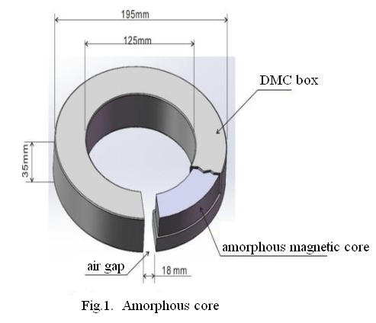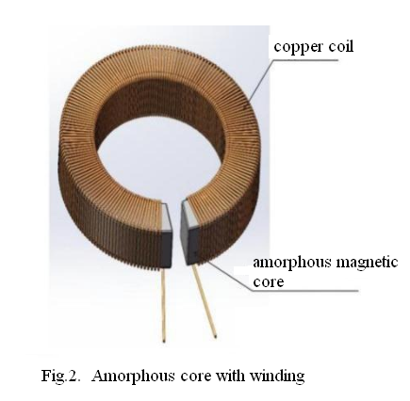

Switching on the coil with AC of frequency f = 50 Hz and voltage V = 50 to 100 volts (adjusting the input voltage with a voltage regulator), and the coil winding current I = 10 A to 50A, which generates an alternating flux at the air gap of the core, and the strength of the magnetic field at the air gap is about 0.1 to 0.5 Tesla (T).

Under normal temperature and normal atmospheric pressure environment, suspending the test material in the air gap by a thin cotton thread, after the coil is energized, it is found that the object of all materials can be moved. Refer to Fig.3.

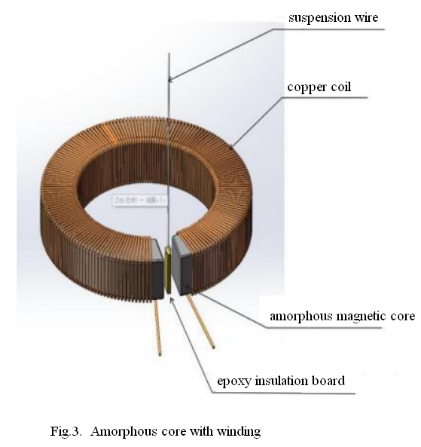

Test materials (the motion effect is obvious when a thin rectangular material is selected) :

1. Epoxy insulating board (Length 41mm×Width 12.5mm×Thickness 1.5mm, Weight 1.5g)
2. Paper (Length 37mm×Width 12.5mm×Thickness 0.11mm, Weight 50mg)
3. Ceramic (Length 30mm×Width 9mm×Thickness 4.0mm, Weight 1.5g)
4. Green leaves (Length 38mm×Width 14mm×Thickness 0.30mm, Weight 125mg)
5. Aluminum plate (Length 40mm×Width 12mm×Thickness 2.0mm, Weight 2g)
6. Fresh pork skin (Length 20mm×Width 10mm×Thickness 3.0mm, Weight 0.5g)

Analyzing the motion of objects at the air gap magnetic field, it is found that a gravitational field is generated at the air gap, which makes the objects of all materials placed in it move. Refer to Fig.4.

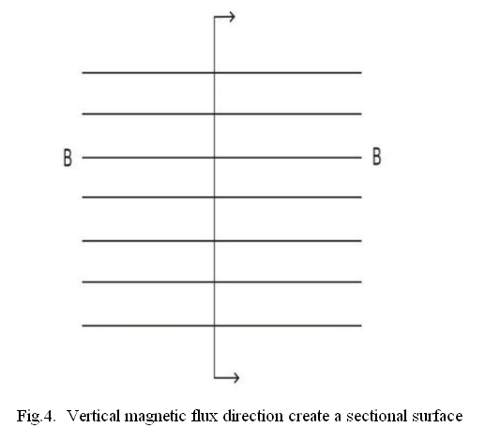

Taking any point on the vertical profile of the air gap magnetic flux, and the direction of the gravitational force on this point may be perpendicular to the direction of the magnetic field from around this point, and converge towards this investigation point, refer to Fig.5. and Fig.6. for gravitational direction.

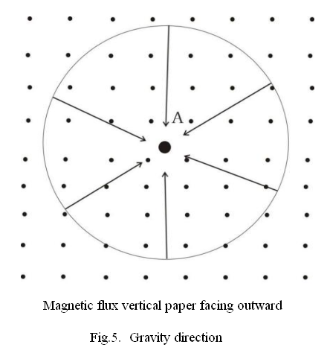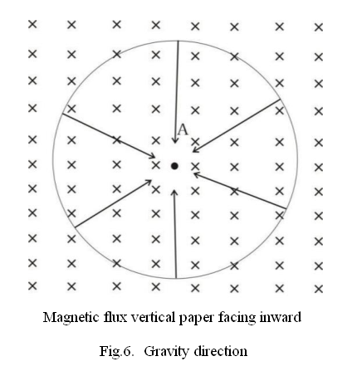

In the process of this experiment, the influence of the vibration after the energized amorphous core and the influence of airflow disturbance in the air gap have been fully weakened. If we use 20V to 60V DC through the coil instead of AC, the effect of the object movement is the same. Refer to Fig.7.

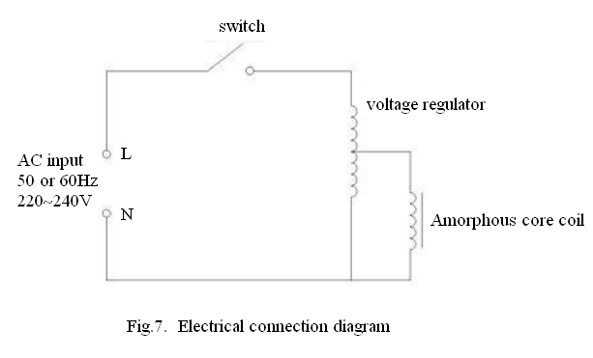

If readers wish to replicate this experiment, it is not necessary to use an amorphous core; other high-permeability magnetic materials may also be used. A coil of 400 to 500 turns can be wound around the core, and an alternating current of 50 Hz or 60 Hz can be applied to the coil. By adjusting the input voltage to between 50 V and 100 V, the motion effect of the object can be observed during the switching on and off of the circuit. This experiment demonstrates the generation of gravitational fields. Based on the observed motion effect, a preliminary mathematical expression of the gravitational field is proposed, as shown in Equations (16) and (17).

$\text{ Differential formula:} ∇×A=\frac{1}{k}B Equation (16)$

A is the gravitational field intensity, k is a constant, and B is the magnetic induction intensity.

$\text{Integral formula:}\oint{A⋅dl} =\frac{1}{k}∯{B∙}ds Equation (17)$

A is the gravitational field intensity, k is a constant, and B is the magnetic induction intensity.

1. **Conclusion**

This study combines theoretical derivation with experimental verification to reveal the generation of gravitational fields within an air gap. The experimental results confirm the existence of a dynamic relationship between gravitation and magnetic fields. Under specific conditions, a changing electromagnetic field can generate a gravitational field. In summary, the experiment provides a reference for further investigation into the relationship between gravitation and electromagnetic phenomena. Future research may explore the effects of air gap dimensions and variations in magnetic field strength on the characteristics of the gravitational field. These studies will further advance the understanding of gravitational fields and provide empirical support for interdisciplinary research between electromagnetism and gravitation.

**References**

[1] Cui, J. H. (2010). The significant role of mechanics in disciplinary development and the national economy. *Engineering Mechanics*, 27(S2), 1–41.

[2] Ruan, X. G. (2023). General Observational Relativity: Why is spacetime curved in Einstein's General Relativity? (Part II) — GOR Theory and Scientific Prediction. *Journal of Beijing University of Technology*, 49(03), 245–324.

[3] Lü, C. Y., Chen, Y. W., Xie, M. T., et al. (2023). First-principles calculation method for periodic systems under external electromagnetic fields. *Acta Physica Sinica*, 72(23), 162–182.

[4] Zhang, X. Q. (2024). *Unified Field Theory: Extraterrestrial Technology – Academic Edition* (2nd ed.).

[5] Huang, Z. X. (2023). On negative wave velocity and advanced waves in electromagnetism. *Journal of Communication University of China (Natural Science Edition)*, 30(06), 64–76.

(*In Chinese*)

[1]崔京浩.力学在学科发展及国民经济中的重大作用[J].工程力学，2010,27(S2):1-41.

[2]阮晓钢.广义观测相对论:时空在爱因斯坦广义相对论中为什么弯曲?(下篇)——GOR理论与科学预言[J].北京工业大学学报,2023,49(03):245-324.

[3]吕程烨,陈英炜,谢牧廷,等.外加电磁场下周期性体系的第一性原理计算方法[J].物理学报,2023,72(23):162-182.

[4]X. Q. Zhang. Unified Field Theory: Extraterrestrial Technology -- Academic Edition(2nd)2024.

[5]黄志洵.论电磁学中的负波速和超前波[J].中国传媒大学学报(自然科学版),2023,30(06)：64-76.

Supplementary Materials

Gravitational Field and Object Motion Generated by Electromagnetic Changes

Xiangqian Zhang, Yuchuan Xu

info@ahdvlp.com

Yuchuan Xu Email: info@ahdvlp.com

Videos of different test materials (epoxy insulating board, paper, ceramic, green leaves, aluminum plate, fresh pork skin) motion in the magnetic field under the action of gravity after the coil is energized.

Movie S1: Video of epoxy insulating board motion in the magnetic field under the action of gravity after the coil is energized.



Movie S2: Video of paper motion in the magnetic field under the action of gravity after the coil is energized.



Movie S3: Video of ceramic motion in the magnetic field under the action of gravity after the coil is energized.



Movie S4: Video of green leaves motion in the magnetic field under the action of gravity after the coil is energized.



Movie S5: Video of aluminum plate motion in the magnetic field under the action of gravity after the coil is energized.



Movie S6: Video of fresh pork skin motion in the magnetic field under the action of gravity after the coil is energized.

